It is recommended that all PIMS sites be upgraded to at least version PIMS 7.3.8, which was released on June 16, 2015. The following document describes known bugs that exist in this version.

Custom Queries 2
Problem with Some Yes/No Fields 2
Standard Reports 3
PIMS 20H: Gestational Age Category shows incorrect data for non-target children 3

Custom Queries

Problem with Some Yes/No Fields
When using the following fields in Custom Queries, the results for yes will appear in the report as false, and the results for no will appear in the report as true.
- Medical Visit form:
  - “Did this visit result in medical treatment for a child injury” [yes/no/unknown]

- Termination form:
  - “Is participant still receiving services at this agency” [yes/no/unknown]
  - “Is participant receiving services at another agency” [yes/no/unknown]

Workaround | Manually reverse the results in these fields

Standard Reports

PIMS 20H: Gestational Age Category shows incorrect data for non-target children
The report header states the following:
* Denotes non-target children; birth date, months enrolled, and hvs prior to birth not shown
The report correctly lists the gestational age category for all children including non-target children. However, the Target Birth Date, Months Enrolled Prior to Target Birth, and # HVs Prior to Target Birth fields list misleading data because these fields reflect the target child even where non-target children are listed. In the example below, for non-target children Kevin Bailey and Stephanie Williams (marked by asterisks), the Target Birth Date, Months Enrolled Prior to Target Birth, and # HVs Prior to Target Birth fields list data not for them but for their target child siblings.
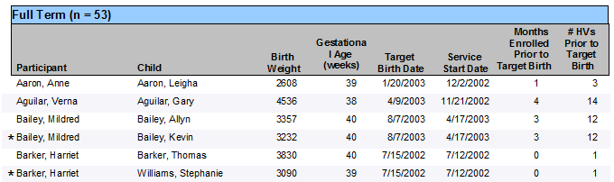

Workaround | Ignore the Target Birth Date, Months Enrolled Prior to Target Birth, and # HVs Prior to Target Birth fields for non-target children.

