How To Install PIMS 8

Overview 2
Before you begin installation… 2
About the PIMS 8 Network Configuration 3
PIMS 8 Configuration for a Citrix Terminal Server (or similar) 3
About the PIMS Data Table 4
I. Configuring Microsoft Access 5
II. Installing the PIMS Program 7
About Remote Access 7
Installing PIMS 7
III. Creating the PIMS Data Table for the First Time 10
IV. Linking the PIMS Program to the PIMS data table 12
Appendix A. Setting up the PIMS Workgroup File on a Network 14
Appendix B. Modifying and Troubleshooting the PIMS Shortcut for Custom Installations 15
Appendix C: Troubleshooting 17

Overview

Before you begin installation…

- Make sure you get all necessary passwords from the PIMS Technical Assistant:
- User Name and Password for access to the PIMS website
- User Name and Password for access to the PIMS program

- If you are installing PIMS for the first time, make sure you know your site’s 5-character Site ID.

- Make sure you know where you will install your PIMS data table, which could be one of the following:
  - On a single computer, if only one staff person will be using PIMS
  - On a network file server, so multiple staff can connect to the same PIMS data table. In this case, you will need to have a network folder where all users have write permissions.
  - On a Citrix Server or Terminal Server.

- Make sure you have a 32-bit version (NOT 64-bit version) of Microsoft Access (or Access Runtime) installed, and that you know which version is on each computer. To determine the specific version:

- Open Microsoft Access.
- If there is a Help menu (Microsoft Access XP, 2007, or 2010)
  - Go to the Help menu and select About Microsoft Access. The version should be listed in the About Microsoft Access window.
- If there is no Help menu (Microsoft Access 2013 or 2016)
  - Click on Blank Desktop Database and then Create
  - From the File menu, select Account
  - Click on About Access. The version should be listed in the About Microsoft Access window.

- If you are upgrading PIMS from a previous version, make sure all PIMS users close PIMS and stay out of the system during the upgrade.

About the PIMS 8 Network Configuration
PIMS is designed to function in a Local Area Network (LAN). The PIMS Application (i.e., pims8.mde and the supporting files needed to run PIMS) is set up on each computer’s local hard drive. The PIMS Data Table (i.e., pimstab8.mdb) can be stored on the server, in order to allow all the local machines to access it. The PIMS Workgroup file, which manages access to data based on user login, can also be stored on the server in order to share user names and passwords across all the local machines.
PIMS Data File
(Back-End Database)
and
PIMS Workgroup
Server
H:\PIMS\PIMSTAB8.MDB
(PIMS data file)
H:\PIMS\SYSTEM_USER.MDB
(PIMS workgroup file)

PIMS
Program
(Front-End
Database)

Workstation 1
PIMS Menus
Forms
Reports

Workstation 2
PIMS Menus
Forms
Reports

Workstation 3
PIMS Menus
Forms
Reports

Remote Access Software

Remote Workstation
(optional)

PIMS 8 Configuration for a Citrix Terminal Server (or similar)
Some sites use a Citrix Terminal Server or similar, in which case each user would have their own folder with a copy of the PIMS application (pims8.mde), and the PIMS data table (pimstab8.mde) would be stored in a shared folder.

PIMS Data File
(Back-End Database)
and
PIMS Workgroup
Server
H:\PIMS\PIMSTAB8.MDB
(PIMS data file)
H:\PIMS\SYSTEM_USER.MDB
(PIMS workgroup file)

PIMS
Program
(Front-End
Database)

User 1
H:\PIMS\USER1\PIMS8.MDE

User 2
H:\PIMS\USER2\PIMS8.MDE

User 3
H:\PIMS\USER3\PIMS8.MDE

About the PIMS Data Table

Once you have installed the PIMS program, you need to create or upgrade the PIMS data table from one computer, and then link to it from the rest. In order for PIMS 8 to run properly in a local area network, it is important that the file storing the PIMS data (e.g., H:\PIMS\pimstab8_IL000.MDB) is created only once when installing PIMS on the first workstation on the network. All other PIMS workstations will attach to that same database file. This will ensure that users from all workstations share the same common PIMS data. After following the instructions in II. Installing the PIMS 8 Program:

- If you are using PIMS for the first time and have no data table from previous versions, follow the instructions in section III. Creating the PIMS data table for the first time. Note that you only need to set this up once for your entire network.

- If you have been using a previous version of PIMS, follow the instructions in section IV. Linking to the PIMS data table. When you link to the PIMS data table for the first time at your site, the data table will automatically be upgraded to version 8.

Configuring Microsoft Access

If you have Office 2010 or newer, be sure to install the 32-bit version. The 64-bit version is not compatible with databases developed in older versions of Microsoft Access, although we plan to upgrade PIMS to 64-bit (tentatively by July 2018).

Microsoft Access 2007 and newer versions have a built-in security feature which can result in annoying security notices. In order to avoid this, you’ll need to configure the folders containing the PIMS application and the PIMS data table as “trusted locations.” If you don’t do this, you may see the following message when opening PIMS:
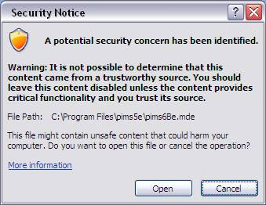
You will also see this message when linking to a PIMS data table, once for each table that is attached (about 50 times when connecting, 100 times when upgrading!).
- Open the Microsoft Access program through your Start menu (typically under All Programs, then Microsoft Office).
- In Access 2007, click on the Microsoft Office Button and then select Access Options from the drop-down menu. In Access 2010 or newer, just click the Access Options tab. In Access 2013 or newer, you’ll have to create a blank database before the Access Options tab is available.
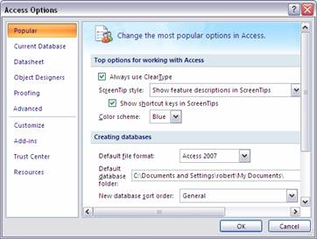
- On the left-hand side of the Access Options dialog box, click the Trust Center tab.
- Click Trust Center Settings…
- In the Trust Center dialog box, select the Trusted Locations tab.
- Check the box next to Allow Trusted Locations on My Network (not recommended).
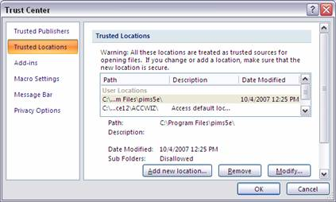
- Click Add new location… This will open the Microsoft Office Trusted Location dialogue box:
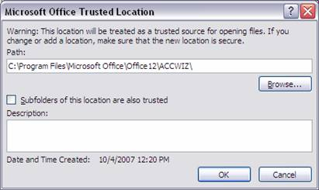
- Click Browse…
- Browse to the location where you installed PIMS (pims8.mde), and click OK.
- Repeat steps 7 through 9 again, this time for the location where you store the PIMS data table (pimstab.mdb).
- Click OK again to close the Trusted Locations box.
- Click OK again to close the Trust Center.
- Click OK again to close the Access Options dialogue box.
- Close Microsoft Access.

Installing the PIMS Program

About Remote Access

PIMS is designed to operate on a local network (see Overview section above). While it is possible to connect to PIMS remotely using a remote access software tool such as GoToMyPC, you will first need to install the PIMS program on a computer connected to your local network. When accessing PIMS remotely, you would then connect to this local computer to operate the PIMS application from off-site.

Installing PIMS

- Go to http://www.hfapims.org/.
- Click on Downloads and Setup.
- In the blue box and under the header PIMS Version 8, click on PIMS 8 Release Installation.
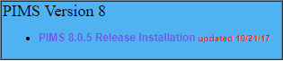
- On the PIMS Installation page, click on the grey Download PIMS Installer button.
- The Authentication Required box may pop up. Type in your PIMS website User Name and Password and click on OK.
- The next step depends on your web browser:

Google Chrome  When the file download is complete, you may see a message:  pims8install is not commonly downloaded and could be dangerous.  Click on the drop-down arrow next to this message and select Keep. | 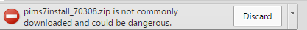
Mozilla Firefox  When the file download begins, you need to choose whether to open or save the file. Choose the radio button next to Open with Windows Explorer and click OK. | 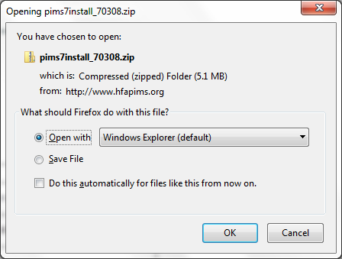

- The pims8install zip folder opens up. On the upper left-hand side of this window, click Extract all files.
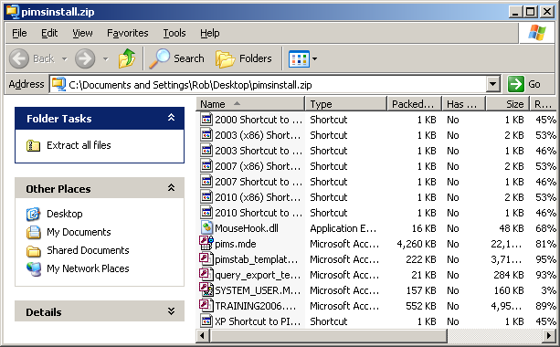
- In the next window, under Files will be extracted to this directory:, click Browse…
- The Select a Destination window (or something similar) pops up. Ordinarily, you will want to navigate to My Computer, then the C: drive, then Program Files.
  - Note: If you are being blocked by security restrictions from installing PIMS in the Program Files folder, you can create the pims8 folder somewhere else such as the My Documents folder. If you’re not sure, check with your local IT support specialist
  - If you get the error message, “File ‘MouseHook.dll’ is either a read only, system, or hidden file. Would you like to replace the existing file,” this likely means that PIMS is already open. Close PIMS and close the installer, and start over.
- In this folder, click Make New Folder, and rename the new folder “pims8” (no spaces).
- Select the pims8 folder, and click OK.
- Back in the Extraction Wizard window, click Extract or Next, making sure Show Extracted Files is checked (if it’s an option).
  - Note: If you get a Confirm File Replace warning, click Yes to All. You’ll only see this message if you’ve already installed PIMS 8 and are just upgrading to a newer release.
- If the pims8 folder you just created is not already open (you can usually find it in My Computer, then C:, then Program Files), open it. Depending on your version of Microsoft Office, one of the several files inside named Shortcut to PIMS 8 should look like a purple key. Drag this to your Desktop.
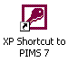
  - Note: If you had to install PIMS somewhere other than the Program Files folder, none of the shortcuts will look like a purple key. Instead, drag the shortcut matching your version of Microsoft Access to the desktop, and refer to Appendix B. Modifying and Troubleshooting the PIMS Shortcut for Custom Installations to help you configure your shortcut.
- If you installed PIMS anywhere other than the default location, follow the directions in Appendix A. Setting up the PIMS Workgroup File on a Network to help you customize your shortcut.
- Right-click on the PIMS shortcut and select Properties. Click on the Compatibility tab, and check the box next to Run as Administrator. Click OK. (Note that for different versions of Microsoft Access, the Run as Administrator option may be in a different tab
- Follow the instructions for setting up the PIMS data table in section III. Creating the PIMS data table for the first time or IV. Linking to the PIMS data table.

Creating the PIMS Data Table for the First Time

Follow this section if…
your site is using PIMS for the first time and you are installing PIMS on the first computer.

Skip this section if…
you have already been entering data into PIMS. Instead, skip to section IV. Linking to the PIMS data table to upgrade your PIMS table from a previous version.

- Open PIMS.
- In the Logon window, leave the name “pims admin” and enter the password given to you by your PIMS Technical Assistant. Click OK.
- If you did not already configure this computer for a training event, when PIMS opens you will see a message, “No PIMS data file currently attached. You need to link to an existing database, upgrade your database, or create a new database.” Click OK.
- The Select a PIMS data File window opens. Click Create New Database.
- From the Pims: Create New Database utility window, click the Dest DB (i.e., destination database) button.
- In the Create New Database window,
  - If you have a network file server:
In the Look in: field, select a network drive and folder where you want to create the database file to store your PIMS data (e.g., H:\PIMS). It is recommended that you place the database in a folder with a meaningful name such as “PIMS”.
  - If you are only installing PIMS on one computer and have no network:
In the Look in: field, the default folder should be pims8. You can place the database here. If you later decide to install PIMS in multiple locations, you can always move the data table to a server and connect to it following the directions in section IV. Linking to the PIMS data table.
- In the File name: field, name the file “pimstab8_yoursiteID.MDB” where “yoursiteID” is your Site ID or an abbreviation of your program name.
- Click the Save button.
- The path and filename you specified for the new database (e.g., H:\PIMS\pimstab8_IL000.MDB) is filled in the blank line on the Pims: Create New Database utility window. Click the Create button.
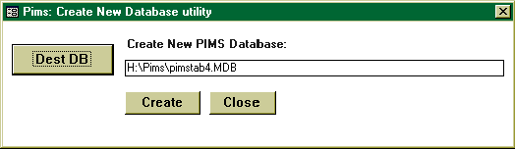
- The Please Wait message will display until the upgrade process is complete. If the upgrade is successful, you will see a message “The new database has been successfully created! The database has been attached to the current program.” Click OK.
- Click Close.

IV. Linking the PIMS Program to the PIMS data table

Follow this section if…
you have been using a previous version of PIMS and need to connect to the upgraded database

Skip this section if…
you used this computer to initially create the PIMS data table following section IV above

If all users have the same network drive mapping for the folder containing PIMS…
you can save time by exiting PIMS on the first computer and simply copying the “pims8.mde” file from the computer used in step III above, into the PIMS folder for each user. This would allow you to skip all of the steps below in this section.

- Open PIMS.
- In the Logon window, leave the name “pims admin” and enter the password given to you by your PIMS Technical Assistant. Click OK.
- When PIMS opens, you will see a message, “No PIMS data file currently attached. You need to link to an existing database, upgrade your database, or create a new database.” Click OK.
- The Select a PIMS File window opens. Click Link to Existing Database.
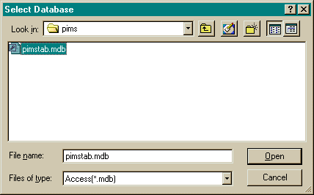
- The Select Database window opens.
  - Browse to select your PIMS data table (usually named something like “pimstab8_IL000.mdb”.
- Click Open.
- You will see a message displaying the current version of PIMS and the version of the PIMS data table. Click OK.
- If the current version and the version of the PIMS data table do not match:
  - You will see a message stating “The PIMS data table will now be upgraded. The new data table will be given the suffix ‘_temp’ until the upgrade is complete.” Click OK.
  - The Please Wait message will display until the upgrade process is complete. You should then see the message, “Database upgraded successfully!” Click OK.
You should eventually see the message, “The data table was successfully attached.” Click OK.

Appendix A. Setting up the PIMS Workgroup File on a Network

Most PIMS sites allow all users to access all PIMS records and reports using the “pims admin” account. However, many sites have policies that encourage improved confidentiality of participant data. It is possible to configure PIMS to restrict each staff member’s access to their own caseload. Following are instructions for setting up the PIMS workgroup file to enable user-based access; for more information about using this once it’s set up, refer to http://www.hfapims.org/software/configure_user_accounts.php.

- Move the PIMS workgroup file from “C:\Program Files (x86)\pims8\system_user.mdw” on one of your local installations to a networkable location. It is recommended that you put this in the same location as the PIMS data table, as described in section III. Creating the PIMS data table for the first time or IV. Linking the PIMS Program to the PIMS data table.
- On each local workstation, you will need to alter the PIMS shortcut to point to this networked workgroup file. Right-click on the shortcut and select Properties.
- The PIMS 8 Properties window opens. Click on the Shortcut tab.
- In the target: box, the text should read something like:

"C:\Program Files (x86)\Microsoft Office\Office\MSACCESS.EXE" "C:\Program Files (x86)\pims8\pims.mde" /runtime /excl /wrkgrp "C:\Program Files (x86)\pims8\system_user.mdw" /user pims admin

- You need to modify the file and pathname “C:\Program Files (x86)\pims8\system_user.mdw” to reflect the actual location where you moved the system.mdw file in step 1. See Appendix B. Modifying and Troubleshooting the PIMS Shortcut for Custom Installations for more info about modifying the shortcut

Appendix B. Modifying and Troubleshooting the PIMS Shortcut for Custom Installations

If you have installed PIMS in any way that is different from the default instructions, you may need to modify the shortcut to PIMS accordingly. The following section describes the general steps for doing this.

- Right-click on Shortcut to PIMS 8 and go to Properties.
- In the top of the PIMS 8 Properties box, select the Shortcut tab.
- The text in the Target box should look similar to the following:

"C:\Program Files (x86)\Microsoft Office\Office10\MSACCESS.EXE"
"C:\Program Files (x86)\pims8\pims8.mde"
/runtime
/excl
/wrkgrp "C:\Program Files (x86)\pims8\system_user.mdw"
/user pims admin

To break this down:

"C:\Program Files (x86)\Microsoft Office\Office10\MSACCESS.EXE" | This specifies the location of Microsoft Access. This will vary depending on what version of Access you have. For example, if you have Access 2003, the last level folder will be Office11.
"C:\Program Files (x86)\pims8\pims8.mde" | This specifies the location of the PIMS program, assuming it is installed on your local desktop (recommended). If it is installed on an application server, for example, the path will be different.
/runtime | PIMS security requires that the database be opened only in runtime mode.
/excl | This prevents the front-end database program from being opened by more than one user, which can cause performance problems.
/wrkgrp "C:\Program Files (x86)\pims8\system_user.mdw" | This specifies the location of your workgroup file, which catalogs the access rights for various users.
/user pims admin | This specifies the default user who is logged in.

- In the Start in: box, modify the string to point to the folder where Microsoft Access is stored. In the example above, this would be "C:\Program Files (x86)\Microsoft Office\Office10".
- If you are implementing user-based access, you will want to install the system.mdw file on the network as well. See Appendix A. Setting up the PIMS Workgroup File on a Network for directions.
- If you are implementing user-based access, you may find it helpful to customize this on each desktop. For example, for a staff member that logs in as “005”, you could change the user section of the string from “/user pims admin” to “/user 005”. Then, whenever someone uses this shortcut to open PIMS on this computer, the default user name will be “005”.
- Click Apply. If your shortcut is correct, you will get no errors.

Error Messages
If the shortcut is not correctly configured, you may see one of the following error messages:

Error Message | Resolution
Microsoft Access couldn’t find file ‘C:\Program Files (x86)\pims8\system_user.mdw’. This file is required for startup. | This means that the workgroup file was not found. If you installed the workgroup file on the network, you will need to modify the shortcuts accordingly (see Appendix A. Setting up the PIMS Workgroup File on a Network)
The drive or network connection that the shortcut ‘Shortcut to PIMS 8’ refers to is unavailable. | The path to Microsoft Access is incorrect in either the Target: or Start in: box. Make sure this corresponds to the version of Access that you have installed.
Can’t find the database file ‘C:\Program Files (x86)\pims8\pims.mde’ | The PIMS program is not in the default location. If you installed the program on an application server or in another folder besides the default, you will need to modify the shortcuts accordingly.

Appendix C: Troubleshooting

If PIMS is not correctly configured, you may see one of the following error messages.

Error Message | Explanation and Resolution
Can’t find the database file ‘C:\Program Files (x86)\pims8\pims.mde.’ | The shortcut is not correctly configured to point to the location of the PIMS program. If you installed the program in another folder besides the default location, you will need to modify the shortcuts accordingly. Refer to Appendix B. Modifying and Troubleshooting the PIMS Shortcut for Custom Installations.
Microsoft Access couldn’t find file ‘C:\Program Files (x86)\pims8\system_user.mdw”. This file is required for startup. | The shortcut is not correctly configured to point to the location of the PIMS workgroup file. If you installed the program in another folder besides the default location, you will need to modify the shortcuts accordingly. Refer to Appendix B. Modifying and Troubleshooting the PIMS Shortcut for Custom Installations.
The drive or network connection that the shortcut ‘Shortcut to PIMS 8’ refers to is unavailable. | The path to Microsoft Access is incorrect in either the Target: or Start in: box. Make sure this corresponds to the version of Access that you have installed. Refer to Appendix B. Modifying and Troubleshooting the PIMS Shortcut for Custom Installations.
Could not use ‘C:\Program Files (x86)\pims8\pims.mde’; file already in use . | This copy of the PIMS application is already open. If you want PIMS to be accessed by multiple users, you need to install the system front-end on each workstation (or in a separate folder on an application server).
This database has been opened read-only. You can only change data in linked tables. To make design changes, save a copy of the database. | Close PIMS. Right-click on the PIMS shortcut and select Properties. Click on the Compatibility tab, and check the box next to Run as Administrator.
Cannot open this file. This file is located outside your intranet or on an untrusted site. Will not open the file due to potential security problems. | Depending on your security settings, this problem may occur even when you don’t install PIMS on an intranet. To solve this, open up C:, then Program Files, then pims. Right-click on pims.mde, and click the Unblock button. Note that if you’re setting up PIMS for training, you may also need to unblock the file training2011.mdb.

