A. Before you begin installation…

- Make sure you get all necessary passwords from the PIMS Technical Assistant:
- User Name and Password for access to the PIMS website
- User Name and Password for access to the PIMS program

- Make sure you know the location on your computer (or Citrix terminal server) where PIMS 8 was initially installed.

- Make sure you know the location on the network where you store your PIMS data table.

- Make sure all PIMS users close PIMS and stay out of the system during the upgrade.

B. Updating the PIMS Program

- Close PIMS, if it is already installed or open, and make sure all users are logged out.
- Go to http://www.hfapims.org/.
- Click on Downloads and Setup.
- Under the header PIMS Version 8, click on the PIMS 8 Installation link.
- On the PIMS Installation page, click on the Download PIMS Installer button.
- The Authentication Required box will pop up. Type in your PIMS website User Name and Password and click on OK.
- The Opening pims8install.zip box opens up. Make sure the Save File radio button is selected, and click OK.
- Locate the file you downloaded, pims8install. Right-click this file and choose Open With… and then Compressed (zipped) Folders (or Windows Explorer for newer operating systems).
- The pims8install zip folder opens up. On the upper left-hand side of this window, click Extract all files.

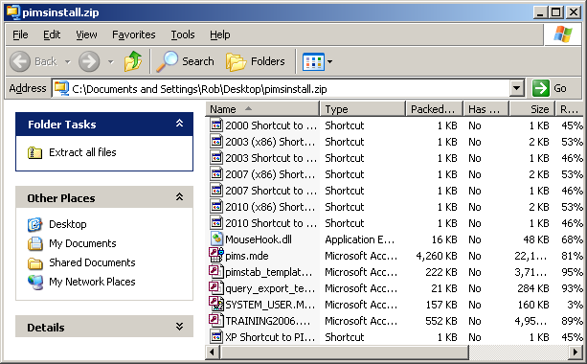
- In the next window, under Files will be extracted to this directory:, click Browse…

- The Select a Destination window (or similar) pops up. Ordinarily, you will want to navigate to My Computer, then the C: drive, then Program Files- assuming this is where PIMS 8 was installed.
  - Note: If you are being blocked by security restrictions from installing PIMS in the Program Files folder, you may have to create the pims8 folder somewhere else such as the My Documents folder. If you’re not sure, check with your local IT support specialist
  - If you get the error message, “File ‘MouseHook.dll’ is either a read only, system, or hidden file. Would you like to replace the existing file,” this likely means that PIMS is already open. Close PIMS and close the installer, and start over.
- Select the pims8 folder, and click OK.
- Back in the Extraction Wizard window, click Extract or Next, making sure Show Extracted Files is checked (if it’s an option).
- You should get a Confirm File Replace warning (or something similar); click Yes to All.
- Click Finish to close the Extraction Wizard.

C. Updating the PIMS Data Table

- Open PIMS using the shortcut on your desktop.
- In the Logon window, leave the name “pims admin” and enter the password given to you by your PIMS Technical Assistant. Click OK.
- When PIMS opens, you will see a message, “No PIMS data file currently attached. You need to link to an existing database, upgrade your database, or create a new database.” Click OK.
- The Select a PIMS File window opens. Click Link to Existing Database.
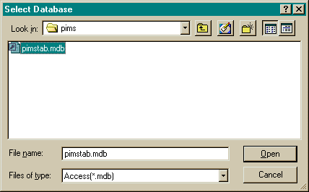
- The Select Database window opens. Browse to select your new PIMS 8 data table (usually named something like “pimstab8_IL000.mdb”.
- Click Open. If this is the first computer on which you are updating PIMS, you may see a message stating “The PIMS data table will now be upgraded.” Click OK. The Please Wait message will display until the upgrade process is complete. You should then see the message, “Database upgraded successfully!” Click OK.
- You should eventually see the message, “The data table was successfully attached.” Click OK.

